

# Aeromodelling Club

IIT Kanpur

CAD DESIGNING PROJECT-2021



**Project Mentors :-**

1. **Mohit Anand**
2. **Raj Agarwal**
3. **Pranshu Singhal**

# **Introduction**

Intro to Aeromodelling:

During the first week of our project we have an introduction to the basics of aeromodelling which includes several components of aircraft,their functioning and the science behind them.We had a quiz on the given intro topics.

CAD designing using Fusion 360:

A series of tutorials were given in order to familiarise ourselves with the installation and working of fusion 360.And then assignments are given on the topics.

Assignment 1: 3D-Drawing

Assignment 2: Design RC remote and Battery

Assignment 3: Freeform of Plane

**Installation**

Step 1: Open web browser and search for ([www.autodesk.com](http://www.autodesk.com/)).

Step 2: Click on fusion 360 as shown in the picture and download the edition for personal use.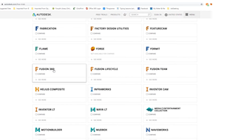

Step 3: Install the software then open it in your device if you already have an account then open it using the registered mail id.Otherwise create account and fill the required details.

Then after creating an account you would get a confirmation mail on the registered mail id.After that you can start your designing journey with AutoCAD Fusion 360.

# **Tools and Commands**

The following are the gist of the tools and commands used during the course of the CAD FUSION 360 project 2021.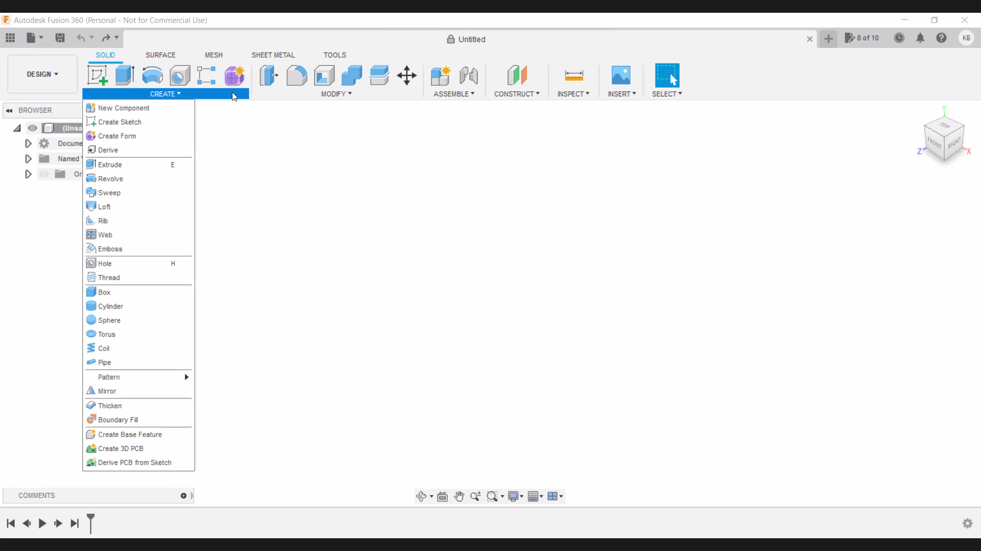

**CREATE:-**

New Component : Creates a new internal or external component in the assembly.

Create Sketch : Enter sketch mode where you can create geometric profiles that define the foundation of a design.

Create Form : Enters Form mode and inserts a Form feature into the timeline.

Extrude : Adds depth to open or close sketch profiles or faces.

Revolve : Revolves a sketch profile or planar face around a selected axis.

Derive : Derive design elements such as components,bodies,sketches,work geometry,flat patterns or parameters from this design to another(new or existing) design.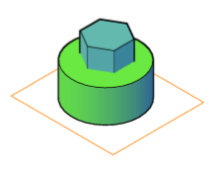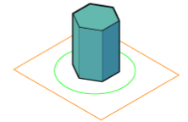

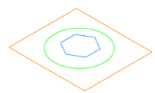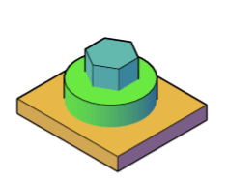

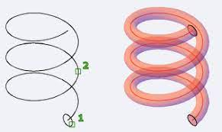

Sweep : Sweeps a sketch profile or planar face along a selected path.

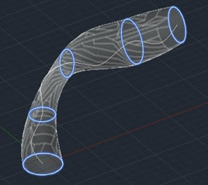

Loft : Creates a transitional shape between two or more sketch profiles or planar faces.

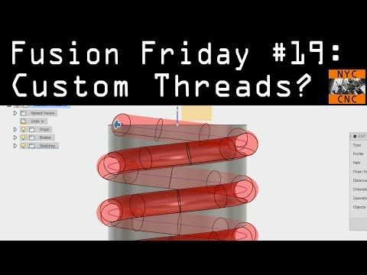

Thread : Add internal or external threads to a cylindrical geometryAlong with these commands CREATE allows to make solid shapes like box,cylinder,sphere,torus,coil and pipe

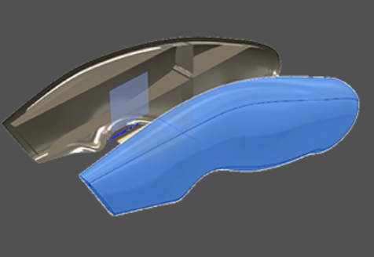

Mirror : Creates a copy of selected faces,bodies,features or components mirrored across a plane.

Thicken : Adds thickness to surface faces to create a solid body.

Boundary Fill : Creates,joints or removes volumes using bounding volumes formed by tools selection.

Hole : Creates a hole based on user specified values and selections.

**MODIFY :-**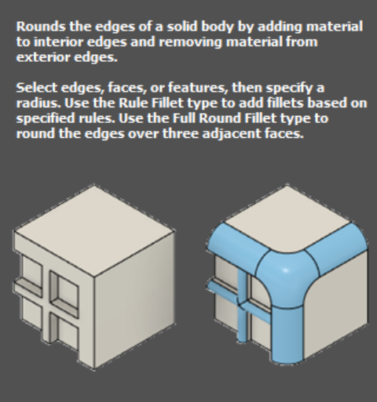

Fillet : Rounds the edges of a solid body by adding material to interior edges and removing material from exterior edges.

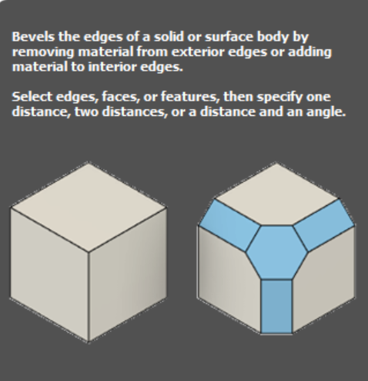

Chamfer : Bevel the edges of a solid or surface body by removing material from exterior edges or adding material to interior edges.

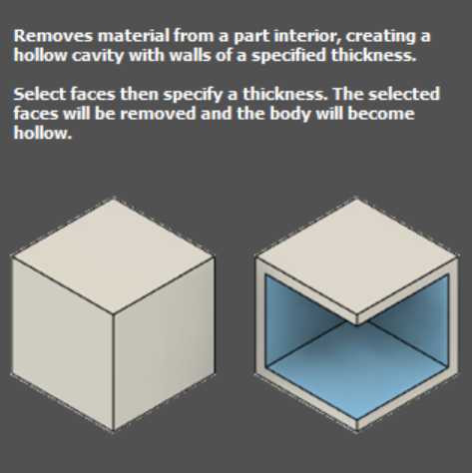

Shell : Removes material from a part interior creating a hollow cavity with walls of a specified thickness.

Scale : Scales sketch objects,bodies , or components.

Physical Material & Appearance : Affects the color, material and engineering of the components.

**ASSEMBLE :-**

Joint : Positions components related to one another and defines the relative motion.

**CONSTRUCT :-**

The construct panel allows us to make various planes axes and points along and through various components,for example,offset plane, plane at angle,tangent plane, midplane,plane through two edges,plane through three points,plane tangent to face at point,plane along path,axis through cylinder/cone/torus,axis perpendicular at point,axis through two planes,axis through two points,axis through edge,axis perpendicular to face at point,point at vertex,point through two edges,point through three planes,point at center of sphere/torus/circle,point at edge and plane and point along path.

**INSERT:-**

Insert Manufacturing Part: we can browse and configure millions of parts from more than 400 suppliers and manufacturer catalogs, and use them in our designs.

Insert Derive: Inserts design elements such as components,bodies,sketches ,work

geometry,flat patterns or parameters from another design.

# **Drawing in Fusion 360**

Fusion 360 Drawings allows you to create 2D drawings from your Fusion 360 designs, which provides the ability to generate PDF and DWG documentation of your Fusion 360 model.When we create a drawing from the Fusion 360 modeling environment, the system automatically launches a new tab of the Drawing workspace and generates a 2D projection of the components you select. The drawing view generated is referred to as a base view. Once you place the base view in the drawing, you can generate orthogonal and isometric projected views from it. A projected view takes the characteristics of a base view and projects it from a different angle.

The Appearance panel provides a variety of display options which we can set as per the requirements. There are various other features like display styles, commands like modify objects, annotate geometry, add dimensions and add notes which itself contains various options to display or to get the required details in 2D drawing of the 3D object.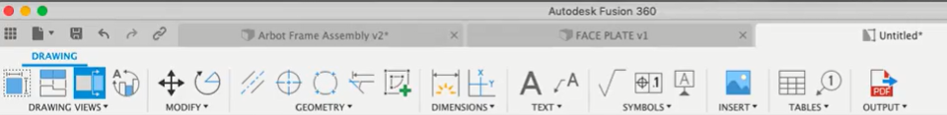

* **Toolbar Commands**
* Create: Display 2D projections of a 3D design on a sheet. The first view we place is the base view. We can project additional views from the base view.
* Modify tools:Move, rotate, and delete objects on a sheet.
* Annotation Geometry:Add center marks, center lines, edge extensions.
* Dimensions: Measure geometry displayed on a sheet.
* Text and Leaders:Point to, label, and annotate important elements on a sheet.
* Symbols:Add surface texture, control frame, and datum identifiers to a sheet**.**
* Image: Add supplemental PNG, JPG, OR TIF images to a sheet.
* Tables: Add a parts list with numbered balloons and bend identifiers to a sheet.
* Export:- Generate a drawing set in PDF, DWG, or DXF format. Generate a parts list in CSV format.
* **Drawing views :-**
* Base View : The parent view from which additional views are generated.
* Projected View : Orthographic views that are projected relative to a parent view**.**
* Section View :A view that cuts through a design assembly along a specific line to reveal the inside.
* Detail View : An enlarged view of a portion of another drawing view.
* **Title Block :-**

In the Drawing workspace in Fusion 360, each sheet has a title block that contains information about the design you are documenting, as well as a border.

Each title block may consist of geometry to help you organize information, text that remains the same on each sheet, attributes for properties that may change from sheet to sheet, images like a company logo or a conceptual rendering of the project.

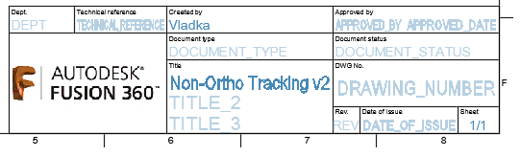

* **Tables :-**

In the Drawing workspace in Fusion 360,we can use the commands in the Tables panel on the toolbar to create tables in a drawing that provides a table which contains names of all the parts used in the object, the appearances applied and description about the various parts.We can also add balloons or bend identifiers to label components in the design as they appear in the table.

# 

# **Assembly**

Assemblies allow us to assemble different components and to make a single object and we can also assign the motion links between different components to simulate how they interact with each other.

**Steps followed to assemble components in Fusion 360**

1. Insert 3D files and also save the files before importing them to the Fusion screen.
2. To get a particular component on screen, right-click on the component and select ‘insert into current design’. It is always a good practice to import large components first.
3. By default, it is inserted at orientation zero. Fix this frame so that other components are assembled. For this, right-click on the component and select ‘ground’.
4. Now bring other components stepwise like step 2, ignore fixing it.
5. Sometimes there is a need to position the two components relative to one another. This criterion is satisfied by choosing the constraint joint.
6. Select the joint command in the assembly section, On selecting the joint, the fixed component turns transparent and highlights various points on the solid component. Select the points on both the components which have to be intact/aligned at any place.Relative motion between the two can be changed by choosing the corresponding motion type under motion. If the components are placed incorrectly, they can be rectified by flipping.
7. Fusion provides us with standard components like nuts, bolts, etc without actually creating them.For this,select insert->manufacturer part ,now a new window pops out, select any company and then the required component or search for the component.
8. Check for the dimensions of the component and the required one, if they match click on To Fusion 360-->login with your credentials. Now the component appears on the Fusion screen.To enable different motions like sliding, revolution at a time, select ‘motion link’ and then select the required points.
9. Select ‘enable all contacts’ in the assembly dropbox to avoid overlapping of two components
10. ‘Motion study’ helps us in changing the duration and angle of rotation.

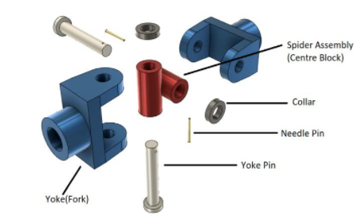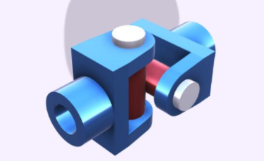

# **Animation**

The Animations workspace in Fusion 360 gives a dedicated toolset and environment specifically for generating exploded views and animations. By selecting the Animation workspace, you’ll notice that the user interface swaps out from the modeling interface to provide the Animation-specific tools and a timeline

.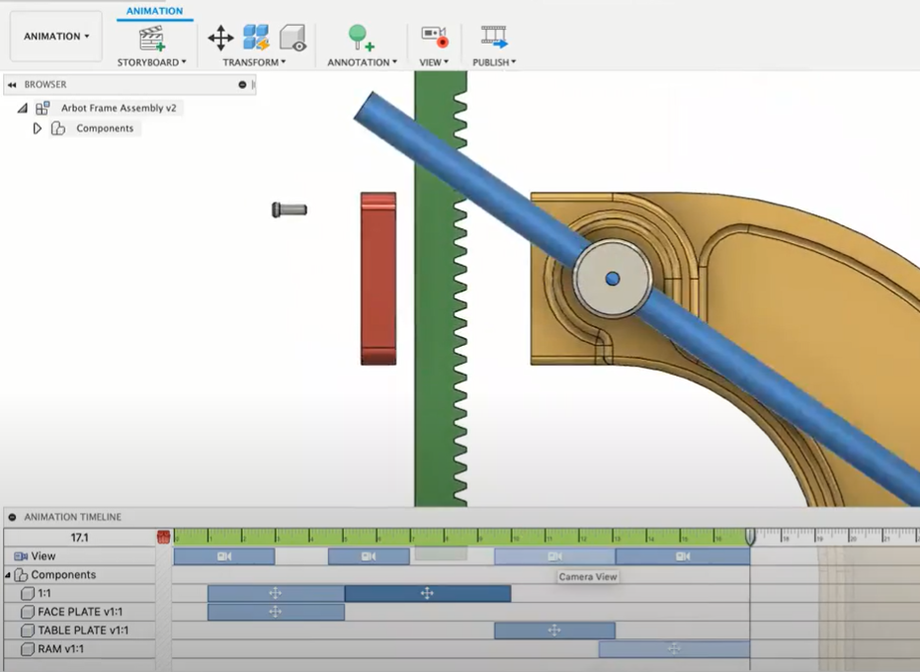

Actions are always created on the animation timeline where the playhead resides, and all actions

can be performed using drag, or their duration can be edited by dragging either end of the action.

There are 5 types of actions:

**1.** Move  **2.** Rotate  **3**. Visibility

**4.** Callout **5.** Camera

We use the Animation workspace to create exploded views and to animate parts and assemblies. Fusion 360 allows you to record the action in animation , using the publish option on the toolbar we can record animations and save it as a video for presentation or analysis purpose The use of Animation is to evaluate and communicate design functionality and illustrate assembly.

# **Simulation**

Simulation is essential for designers to justify their design with a given set of criteria.

Fusion 360 is in-built with simulation. A couple of simulation samples are present by default in the sample projects of fusion 360 software.

We can convert those samples into simulations by going to Design -> Simulation.

After this simulation, the user interface gets changed, and we get a new toolbar for simulation work, and we can create different types of studies under the simulation toolbar.

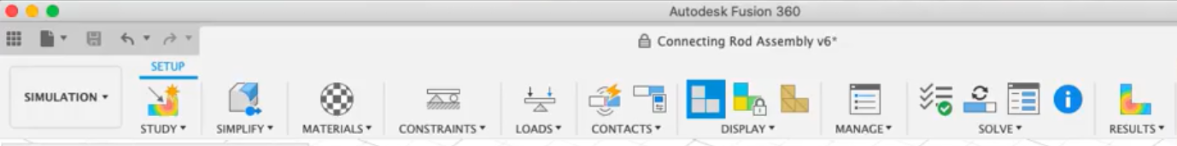

The step by step setup process for simulation is evident in the toolbar itself, which is as follows:-

* Study-We create a study for our simulation.
* Simplify - We simplify the 3D model of our simulation.
* Material - We choose the material of our model
* Constraints - We set the constraints
* Loads - We can add loads to our model components
* Contacts - We convert joints into contacts before we go for simulation
* Display - We choose which type of model we wish to see, e.g., mesh, normal, etc., that display we can change here.
* Manage - Here, we can manage and edit the settings of our model.
* Solve - We first perform a pre-check, and we see the green check, after which we solve the simulation case either on the cloud or locally. Cloud solves the issue faster than local solving and takes a couple of seconds.
* Results - We get the results of our simulation. We can use result tools to extract the report results and more.

Steps that you take to perform desired actions for a **Simulation** analysis are as follows :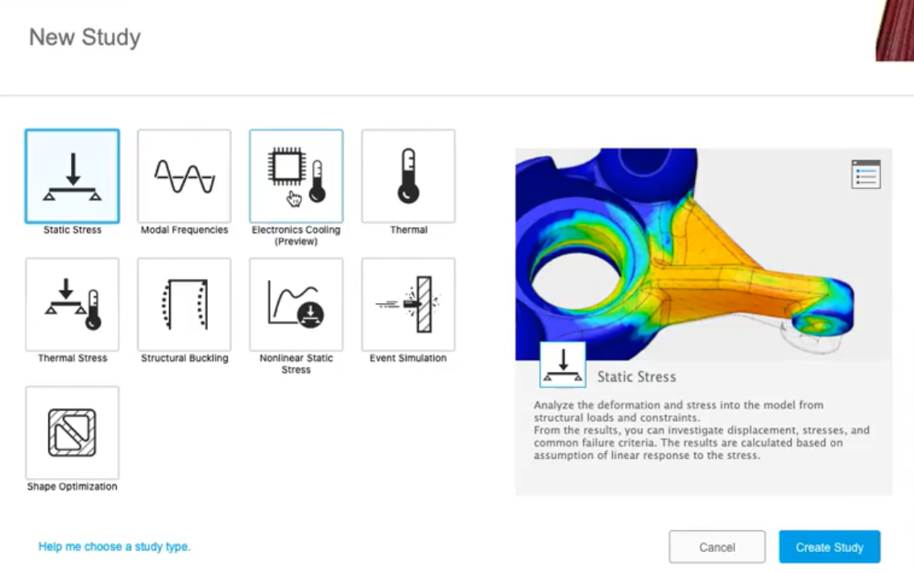

* Set up a simulation study
* Modify your model
* Control mesh quality
* Apply materials
* Apply constraints
* Apply loads
* Generate contacts
* Display
* Solve a simulation

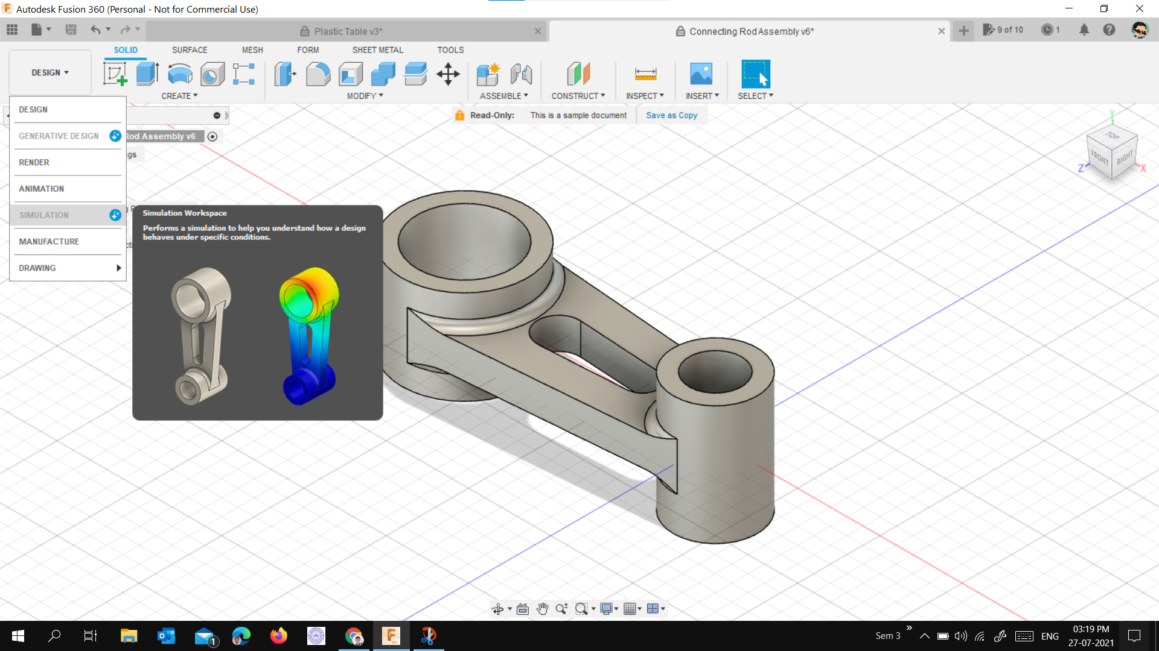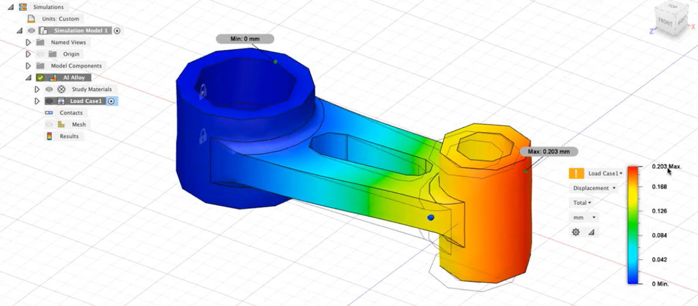

The output of a finite element analysis (FEA) solver is generally a substantial quantity of raw data. This data is difficult and tedious to interpret without graphical representations. Contour plots are graphic displays representing the distribution of stresses, deformation, temperature, and other results, using various colors. A vital aspect of a simulation analysis is the proper interpretation and evaluation of these results.

# **Generative Design**

Generative design is a design exploration process which is inbuilt in Fusion 360. We input our design goals along with parameters such as load, materials, manufacturing method and various constraints. The software gives us all possible solutions for our data entered. We can choose our desired design from them.

The process can be broken down into various steps.

1. Model the part

It is convenient to have a starting model shape which includes all the essential parts. This can be completed using standard modelling techniques.After completing this, change your mode to generative design, where you can see a new user interface.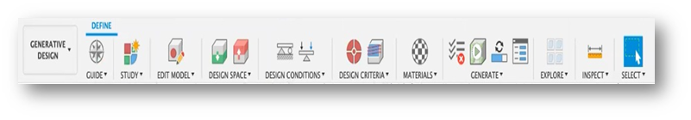

2. Model the obstacle and preserve geometry

Obstacles are areas in the design where we don’t want generative design to allow materials to enter. These are not included in the original design. This includes nuts, bolts, screws, pins, etc. Also make sure your obstacles clear the envelope of the problem setup.Preserved regions are areas where we want to maintain the size and shape that we define in the model.

3. Set up boundary conditions

Specify the constraints, loads, manufacturing details, and materials into the software as per the requirements of the project. You can now preview your design to check if you have forgotten any specific detail.

4. Choosing from the solutions

The software will give you many outcomes based on the data entered. It will also recommend some of them. Closely check them and choose the design you desire.

After choosing the design, the generative design window will change to freeform mode. There you can again make changes.

Now, you can cross check your results using simulation mode. 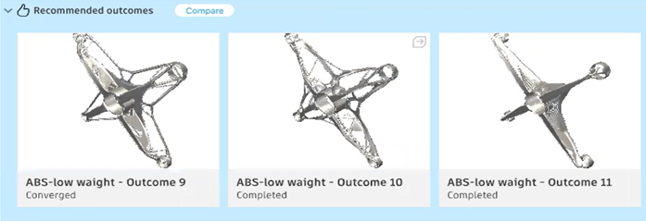

# **Free Form**

It is the most natural and organic way to approach any designing problem. Fusion 360 uses T-spline model to define the surfaces created using free form modelling.In this we have surface composed of several vertices,edges and surfaces each of which serves as a control parameter and can be easily modified (i.e translated, scaled and rotated) to give us any surface we desire .

1. First get into free form design mode by clicking create form in create workspace.
2. Get the initial shape of the new body by any suitable manner(by drawing in sketch mode and extruding it or choosing any simple shape given).
3. Modify the object using the various commands available in the modify menu ,apply appropriate constraints(symmetry,dimensions etc)
4. Fine tune the object using various options like (Smooth,Flatten,Make uniform etc).You can also give thickness and apply materials.
5. Make sure that there are no conflicts and then finish the form.



Useful tools: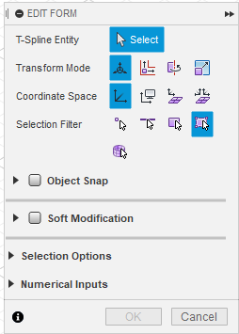

Modify menu contains various tools and utilities ,some of them are as follows

Edit form:This command helps you to edit the shape ,size and the orientation of the surface.

Insert Edge and Subdivide:Divides the surface into smaller subunits of appropriate size giving you greater control

Fill hole: completes the open part of the surface ,with a smooth surface giving various patterns and options to do so.

Thicken: Gives thickness to the given surfaceSmooth,Flatten,Straighten: Help in altering the profile of the surface as suggested by their name.

Weld and Unweld Vertices: The help in joining and disjoining the vertices while trying to maintain an overall smooth profile.

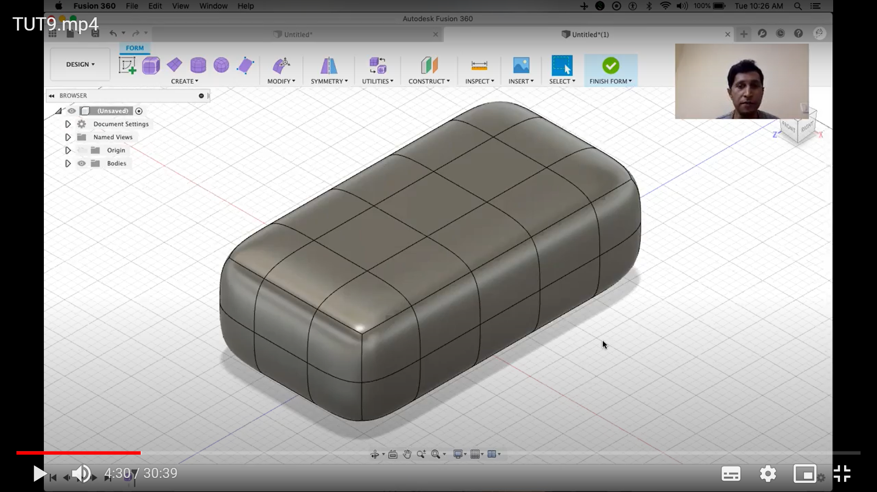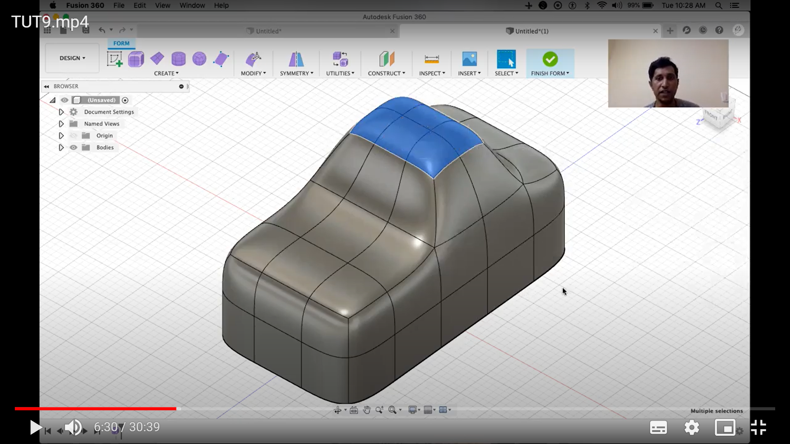

# 

# **Wing and propeller design**

# Airfoils , propellers , empennage can be designed in fusion 360 either by inserting design or image as a canvas on a plane to trace the sketch and extrude it.This is not very efficient in terms of manufacturing, a more accurate way is to insert or import actual data used in these parts.

* **Way to insert data for Airfoil :-**

1. Open fusion 360. Click on add-ins, search for Airfoil DAT to spline , and download the suitable resource.
2. Now find a dat file which is a list of all the spline coordinates for the airfoil of an aircraft by copy pasting it on notepad and saving it with .dat extension.
3. Again, open fusion 360 and click on add-ins. Now, click on scripts and add ins.
4. You will find the airfoil dat to spline script which you downloaded earlier , click on that select plane and other options , then add that dat file which the software itself asks for.
5. This will make the airfoil design outline; now you can edit and extrude this feature.

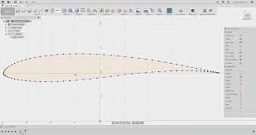

Similarly,propellers and other parts can be done.

Reference videos :-

1. Airfoil design :-<https://youtu.be/nuC16wZahsA>

2.Propeller design :-<https://youtu.be/ZGszDz0tlRY>

# **Assignments**

## **Assignment 1**

As a part of assignment 1 of the project, we were required to make the following solid.

Step 1 : We drew the sketch of the given object using the “Create Sketch” command and applied necessary constraints.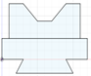

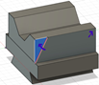

Step 2 : The above figure is in 2-D plane so we convert it into 3-D shape using “Extrude Command”.

Step 3 : As shown in figure some extra parts(in blue color) are included which are needed to remove .For this, we draw a triangle( as indicated in above figure in blue color) on both corner(indicted by blue arrow ) and we remove this feature using the extrude feature but in the opposite direction. We repeat this process on both corners (indicated by the yellow arrow ). 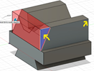

## **Assignment 2**

As a part of assignment 2 of the project, we were required to make the following RC.

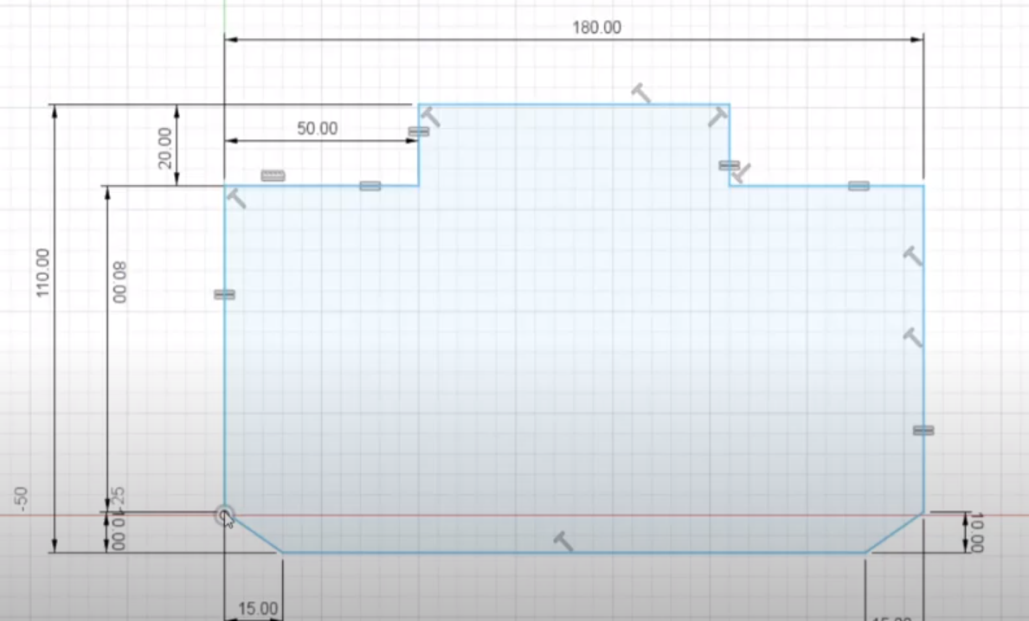

Step 1 We start by making the sketch of the RC and extrude it to 3D.

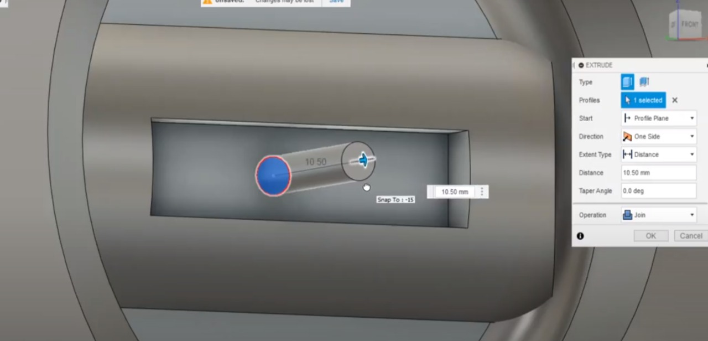

Step 2 Then we make space for the joysticks and extrude the joysticks.

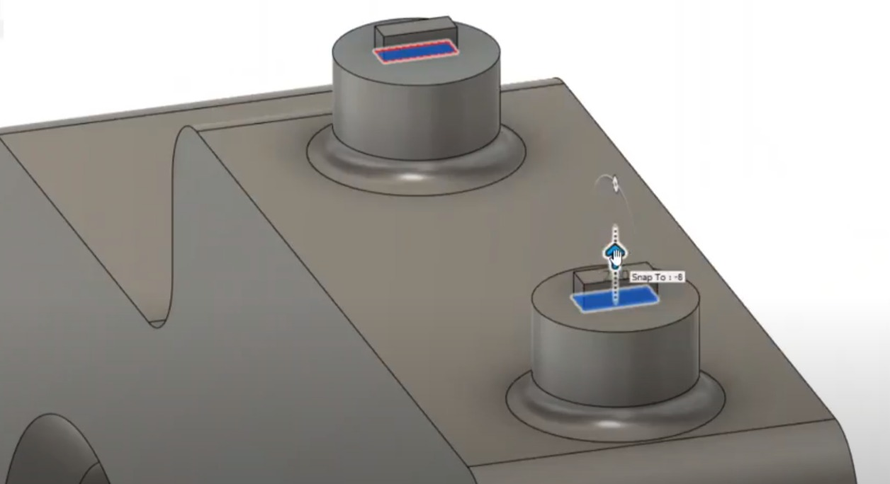

Step 3 Then we construct the hinges for placement of antennae.

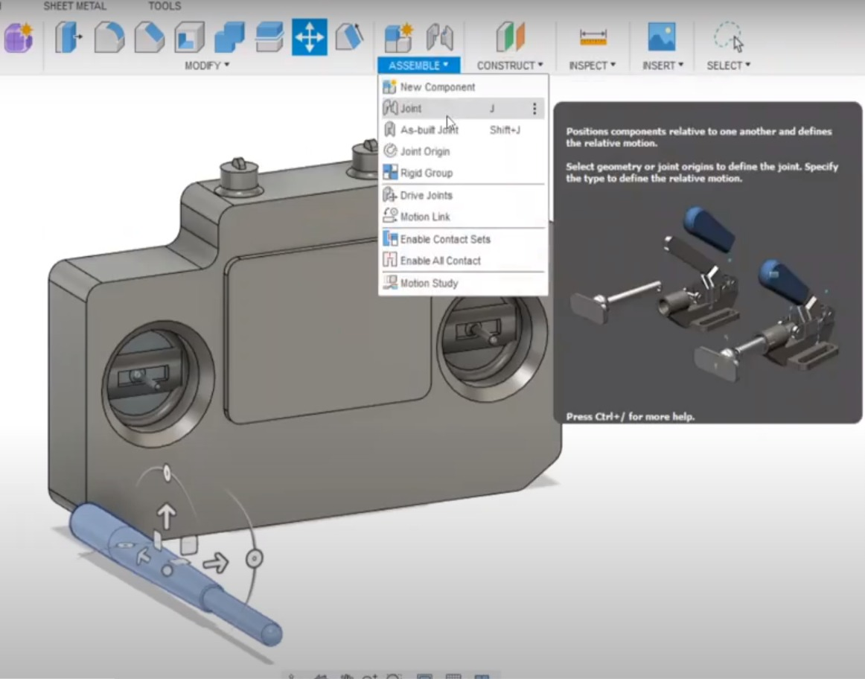

Step 4 Now by using assembly we assemble the antennae and join to the RC by joint command.

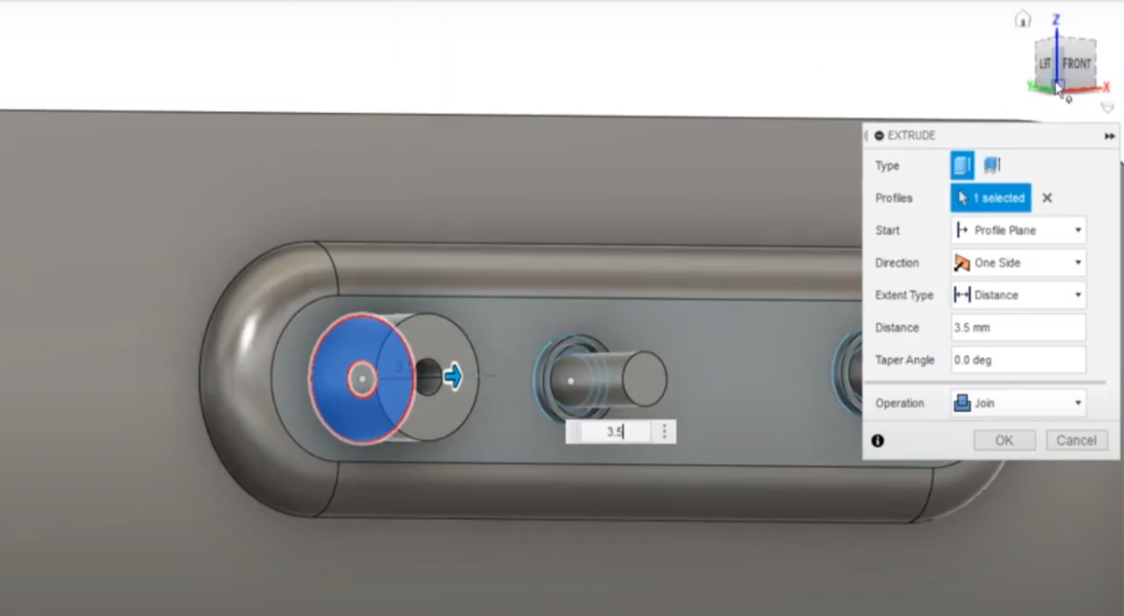

Step 5 After that we make various parts of RC

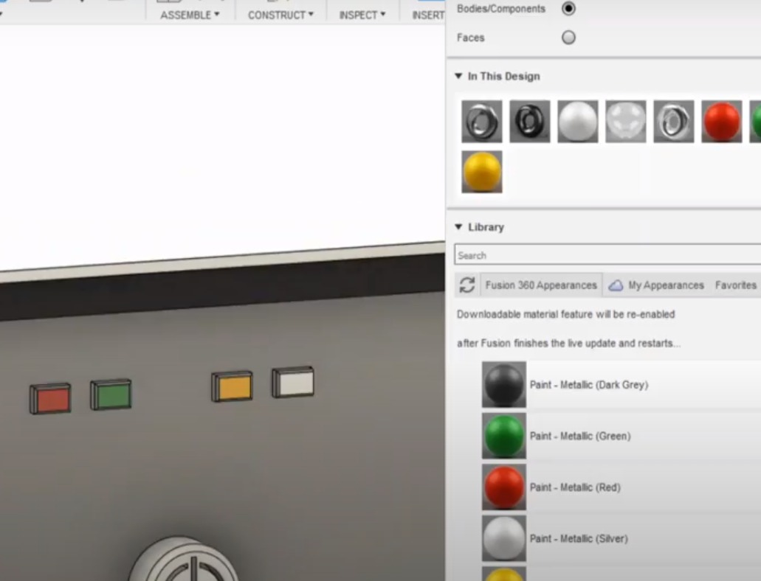

Step 6 Now we start changing the appearances of various parts accordingly

## **Assignment 3**

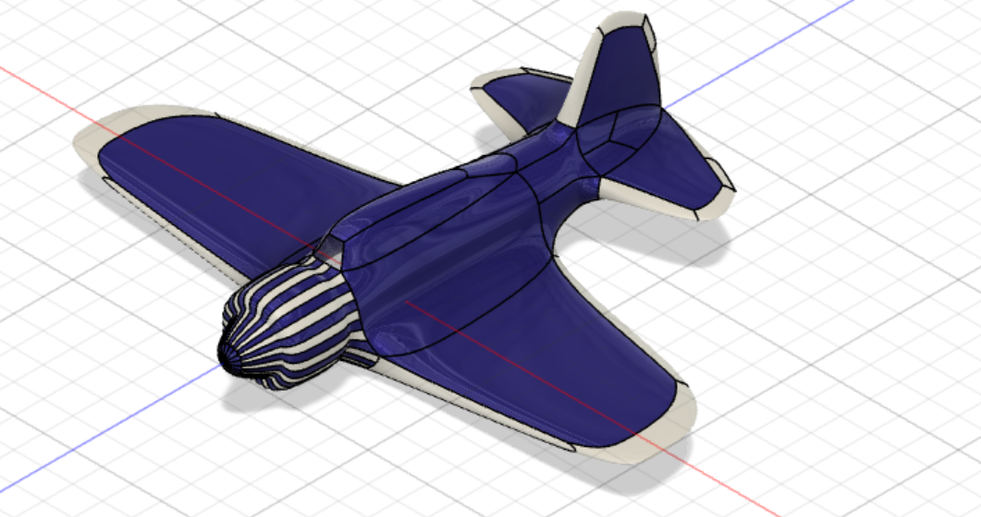

In this Assignment 3 of CAD designing project ,we are required to design a plane using freeform in Fusion 360.

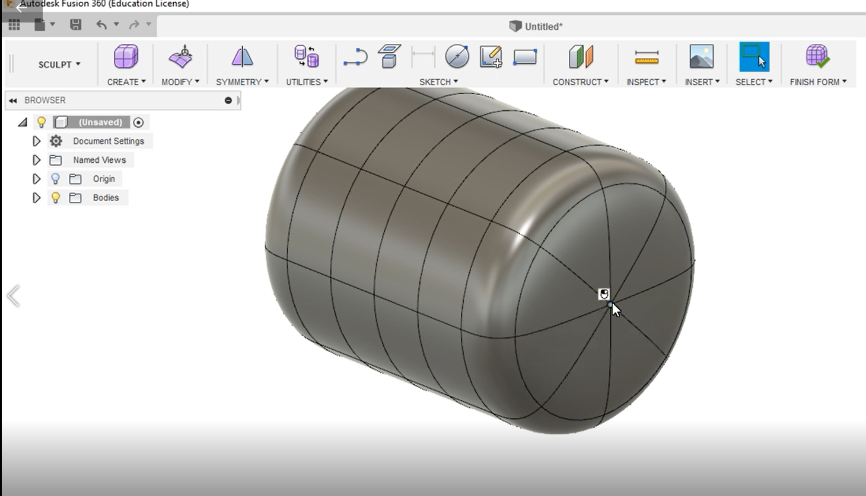

Step 1 : First we make a cylinder using the ‘Create’ option and adjust its diameter and height of proper length. Now fill the two ends of the cylinder using the “fill hole” in the Modify option.

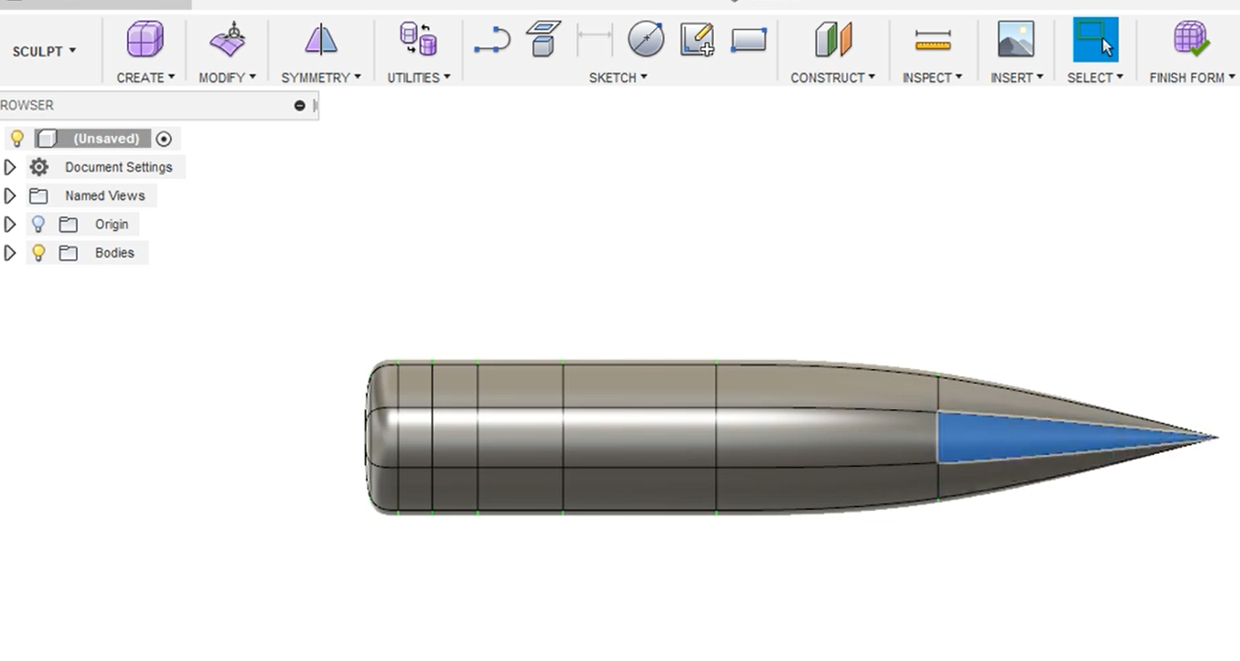

Step 2: Select the center point. Using “Edit Form”,stretch its center point to a required length. Now using “Symmetry” ,select any two opposite faces on the conical part of the model.

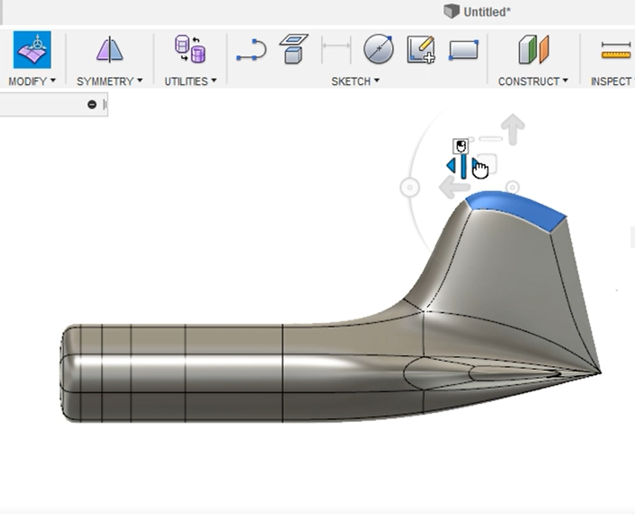

Step 3: Make Horizontal Stabilizer of the plane by first selecting a face and then using “Edit Form” .Press Alt+Drag to adjust the length. Similarly ,make Vertical Stabilizer and Wings too.

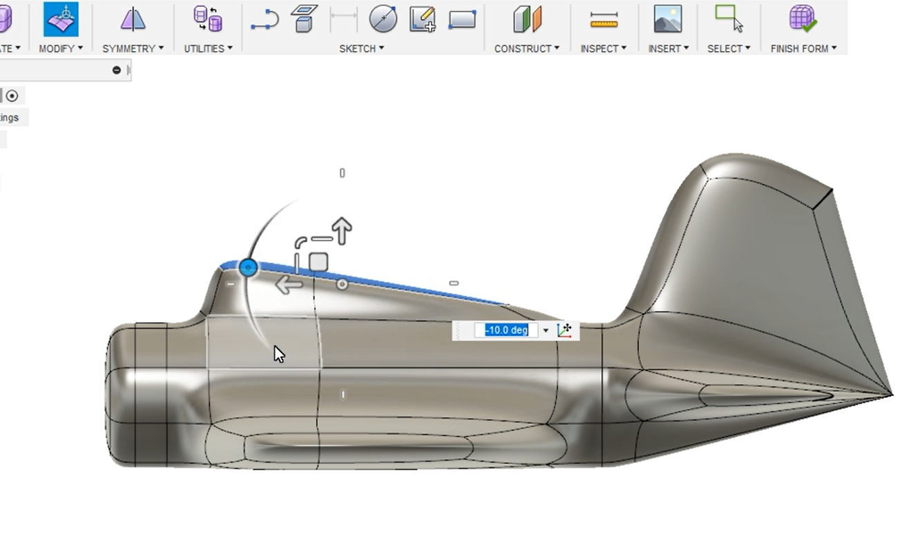

Step 4: Now make the Cabin of your plane using “Edit Form”. Adjust its length and orientation.

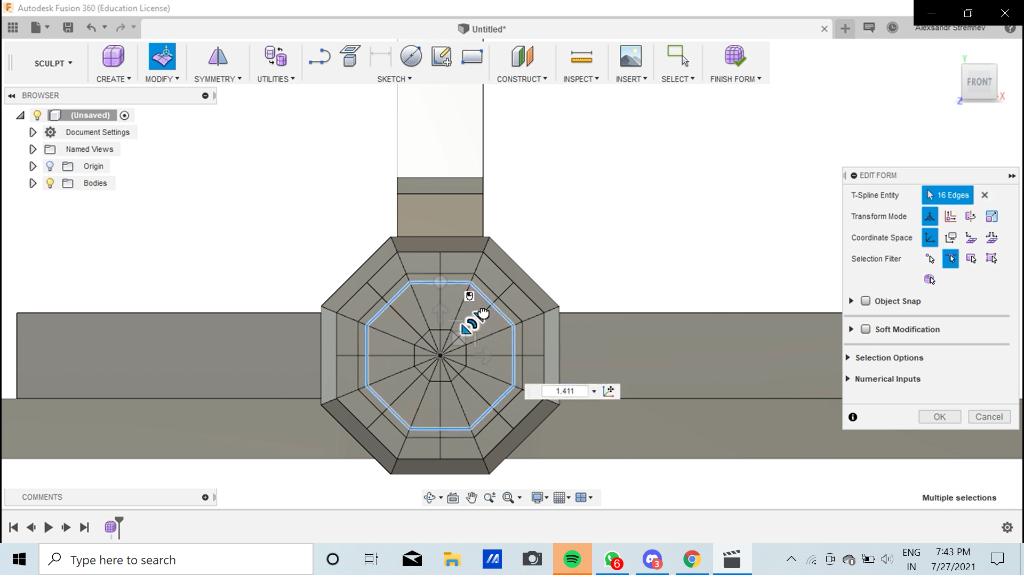

Step 5: Adjust the display mode by Alt+1 Command. Now using the “Subdivide” option, divide the mouth of the model . Then select its faces and adjust it.

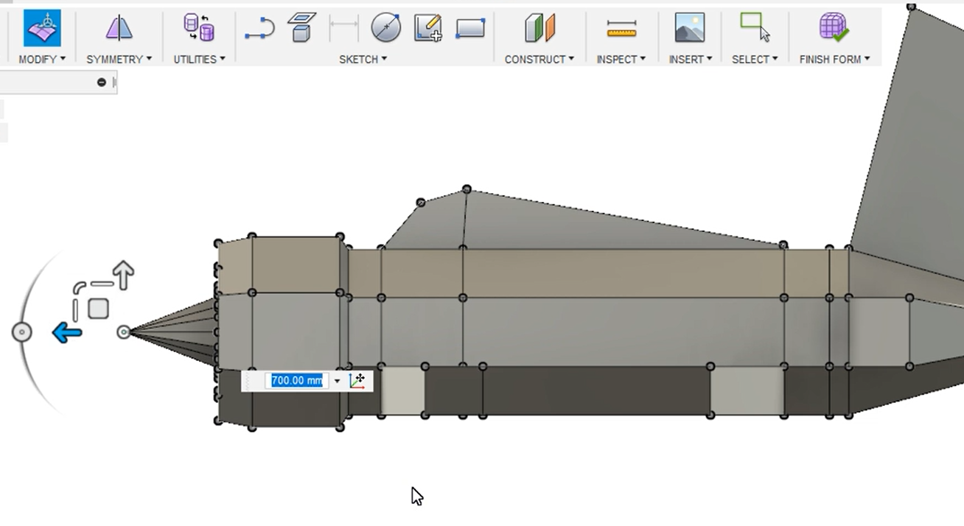

Step 6: Select the center point of the mouth of the plane. Adjust it to proper length by Alt +Drag Command.

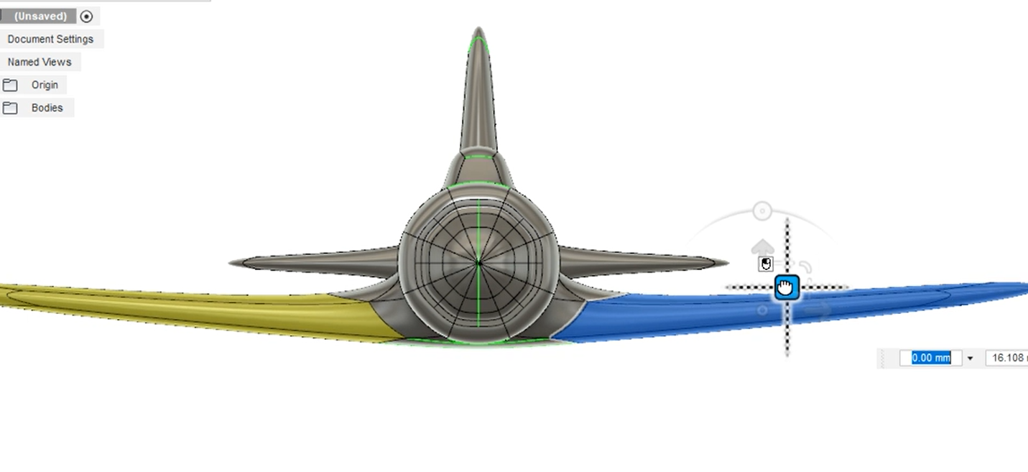

Step 7: Adjust wings and all the parts properly

Once again . Now colour it to finish the look by “Appearance” command.

# **Designathon**

[1]

[**https://a360.co/3iXK6Vf**](https://a360.co/3iXK6Vf) **https://a360.co/3x4oN9G** [**https://a360.co/3y9sah3**](https://a360.co/3y9sah3)

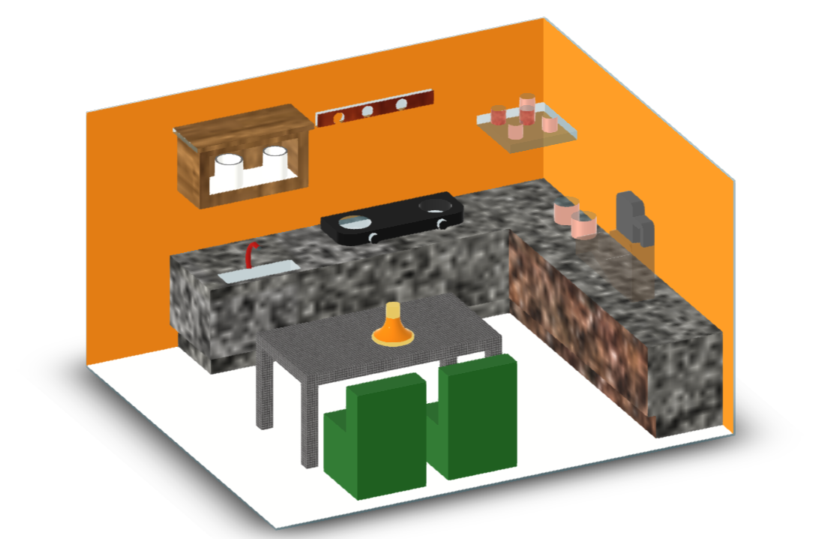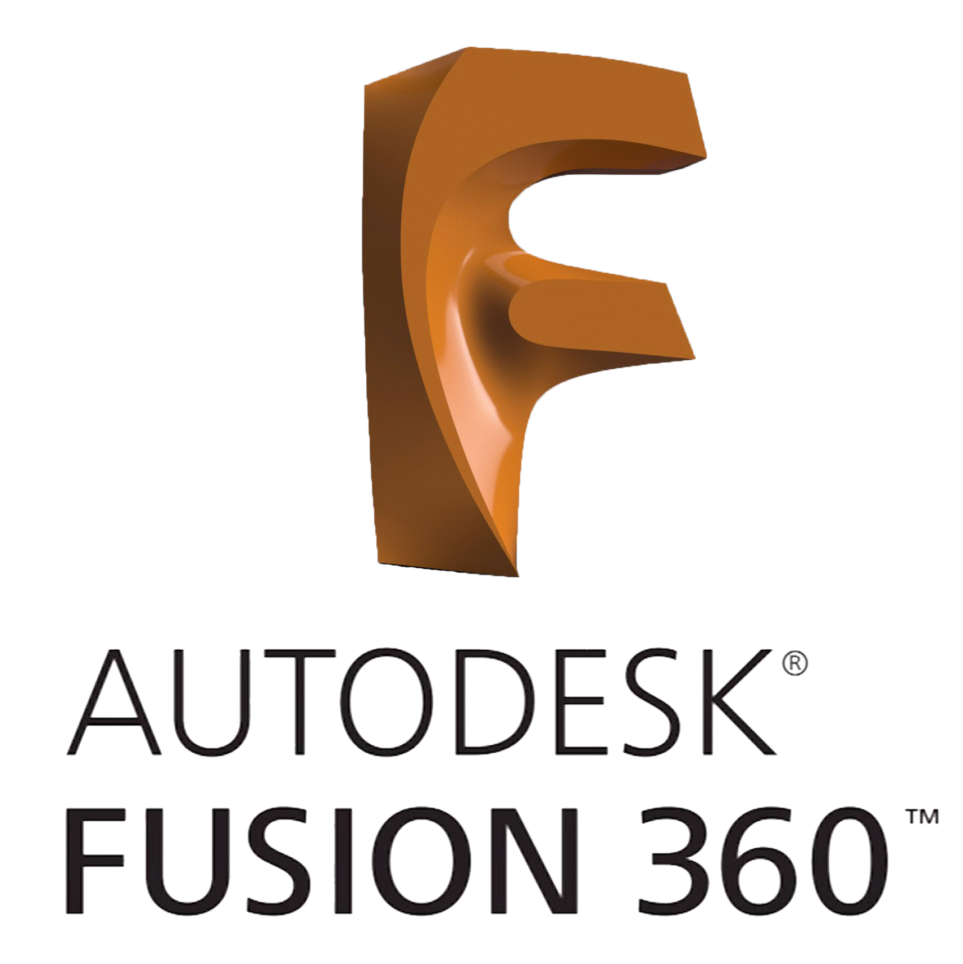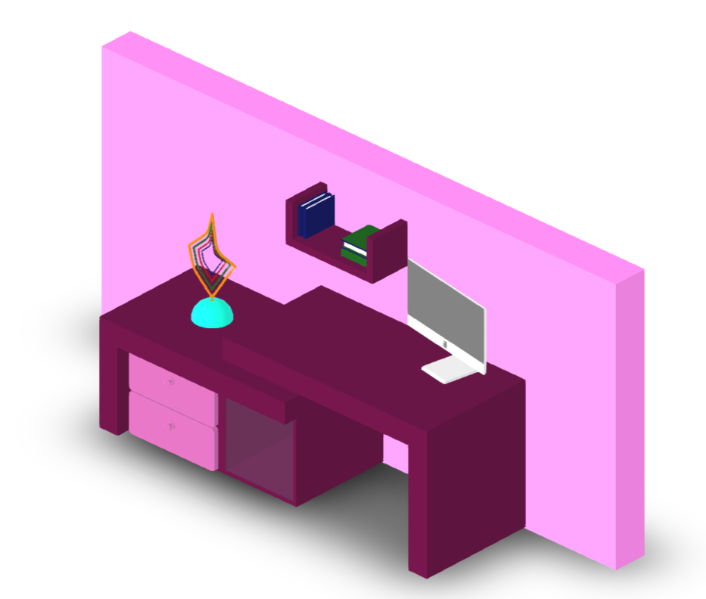

[**https://a360.co/3l5Nbpg**](https://a360.co/3l5Nbpg) [**https://a360.co/3rE2mXK**](https://a360.co/3rE2mXK)

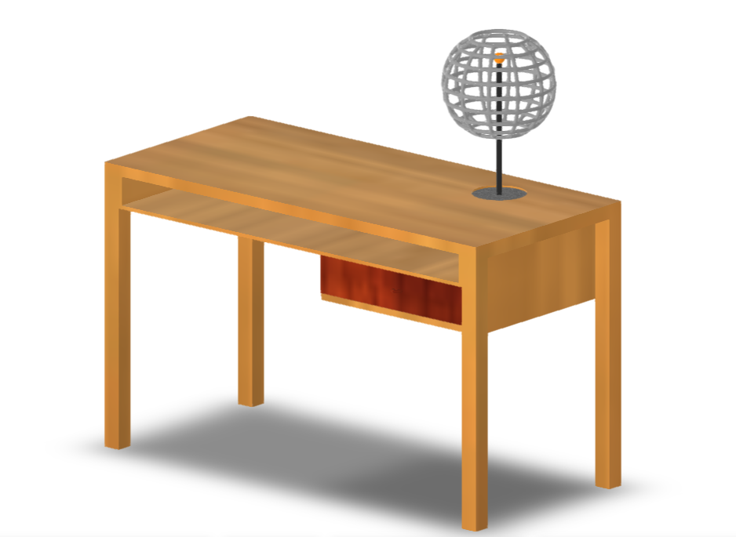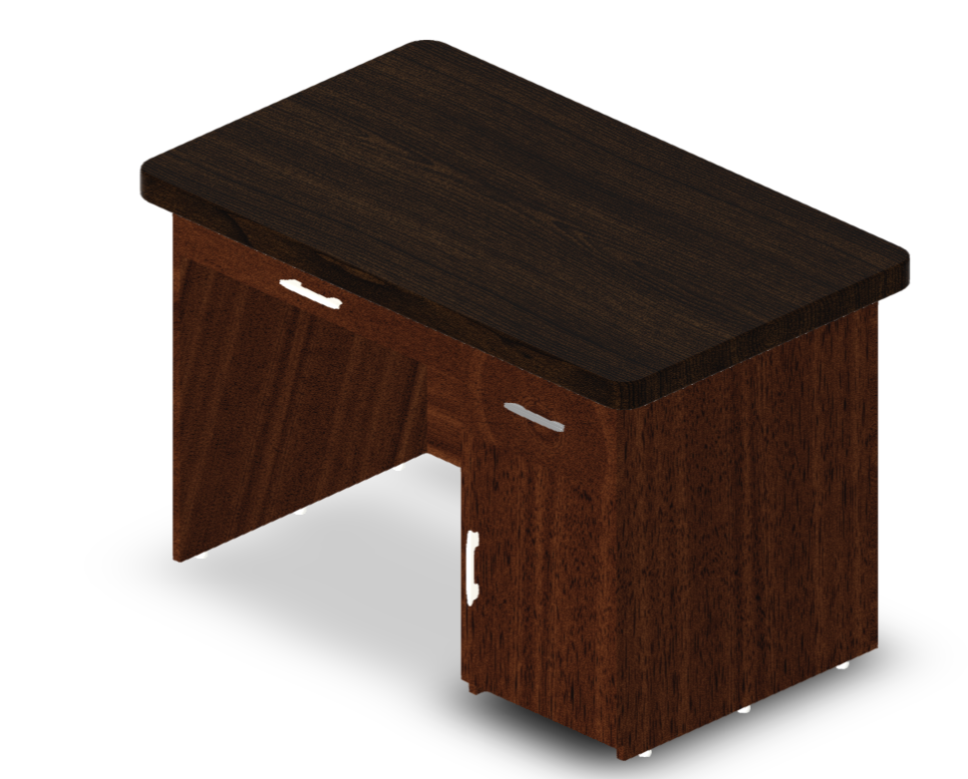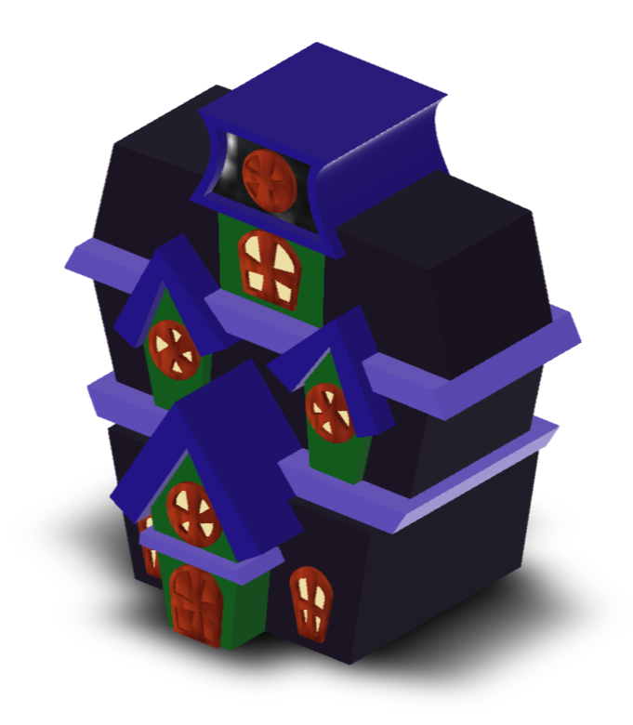

# **Thank You**

**CAD DESIGNING PROJECT TEAM**

1. [**https://a360.co/3A6sE96**](https://a360.co/3A6sE96) [**https://a360.co/3zJfJsr**](https://a360.co/3zJfJsr) [**https://a360.co/3A6sE96**](https://a360.co/3A6sE96)